# EXCEPTION AND PITFALL INSPECTION

**Team 3:** D-Encoders

**Project's name:** Ferrinventory

**Inspection by team 2:** BugBusters

**Code version:** 0.4

**Date:** Wednesday, june 21th, 2023

**INDICATOR 1: Exceptions**

**Aspects to corroborate:**

* **Problem:** Check with letters

**Consequence:** The program stops running because it has an error.

**Evidence:** 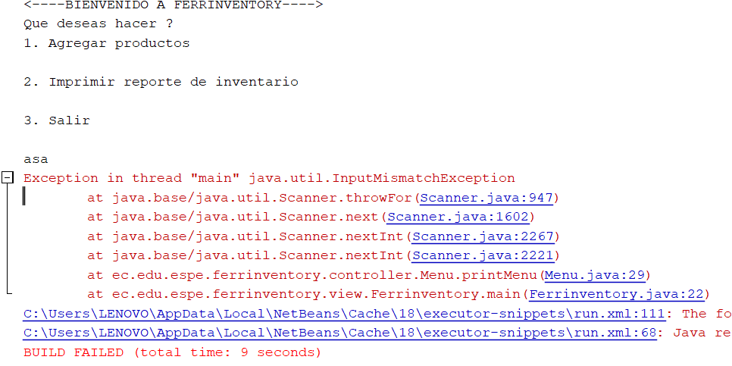

* **Problem:** Check with negative numbers.

**Consequence:** The program doesn’t perform any action.

**Evidence:** 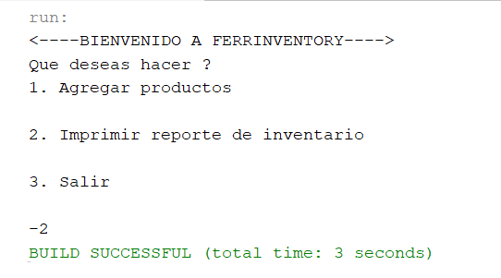

* **Problem:** Check large numbers

**Consequence:** The program stops running because it has an error.

**Evidence:**